|  |  |
| --- | --- |
| **Name** | **Muhammad Nasir Abdullah khan** |
| **Reg no** | **SP20-BSE-038** |
| **Subject** | **Mobile Application Development** |
| **Assignment lab** | **2** |
| **Submitted To** | **Sir Kamran** |
| **Date** | **28/10/2022** |

**Code:**

import { StatusBar } from 'expo-status-bar';

import { StyleSheet, Text,Button,View ,image,ImageBackground } from 'react-native';

import { TextInput } from 'react-native-web';

const pic={uri:"https://th.bing.com/th/id/R.aaa3715b1d25ebda80321dff39be6f02?rik=XER%2bHbQhB3g7DQ&riu=http%3a%2f%2fcaptainkimo.com%2fwp-content%2fuploads%2f2012%2f11%2fwpid17294-Sunrise-at-Pine-Forest-and-Palm-Scrubs.jpg&ehk=HDK8jyiVelsnmb6TZyjMi1PCaMRKXrqudi6VWsSW7FI%3d&risl=&pid=ImgRaw&r=0.png"};

export default function App() {

return (

<View style={styles.container}>

<ImageBackground source={pic}

style={styles.image}

blurRadius={2}

>

<Text style={{flex:1,color:'white',fontStyle:'italic',textAlign:'center',

fontSize:100,justifyContent:'flex-start',alignItems:'center', fontWeight: 'bold'}}> path</Text>

<View style={{bottom:120,height:20,width: 300,color:'white',textAlign:'left',right:60,

fontSize:20,justifyContent:'flex-start',alignItems:'left', fontWeight: 'bold'}}>

<TextInput style = {styles.iinput}

placeholder = 'Email Address '

></TextInput>

</View>

<View style={{bottom:90,height:20,width: 300,color:'white',right:60,

fontSize:20,justifyContent:'flex-start',alignItems:'stretch', fontWeight: 'bold'}}>

<TextInput style = {styles.iinput }

placeholder = 'Password'

></TextInput>

</View>

<View style={{bottom:60,height:20,width:100,color:'white',left:8,

fontSize:20}} >

<Button title="Register" color="transparent" ></Button>

</View>

<View style={{ bottom:5,height:30,width:400,alignSelf:"stretch",color:'white',left:1,

fontSize:100}} >

<Button title="Login" color="red" ></Button>

</View>

</ImageBackground>

</View>

);

}

const styles = StyleSheet.create({

container: {

width:400,

height:400,

alignSelf:'center',

},

image :{

width:400,

height:400,

alignself:'center',

justifyContent: 'center',

alignItems: 'center',

},

txt:{

color:'white ',

fontSize:100,

justifyContent: 'center',

alignItems: 'center',

},

iinput: {

borderWidth : 1,

borderColor : 'white',

backgroundColor:'transparent',

textShadowColor:'white',

borderRadius : 3,

width : 400,

height : 35,

padding : 10,

margin : 10,

color: 'white',

}

});

**My Design:**

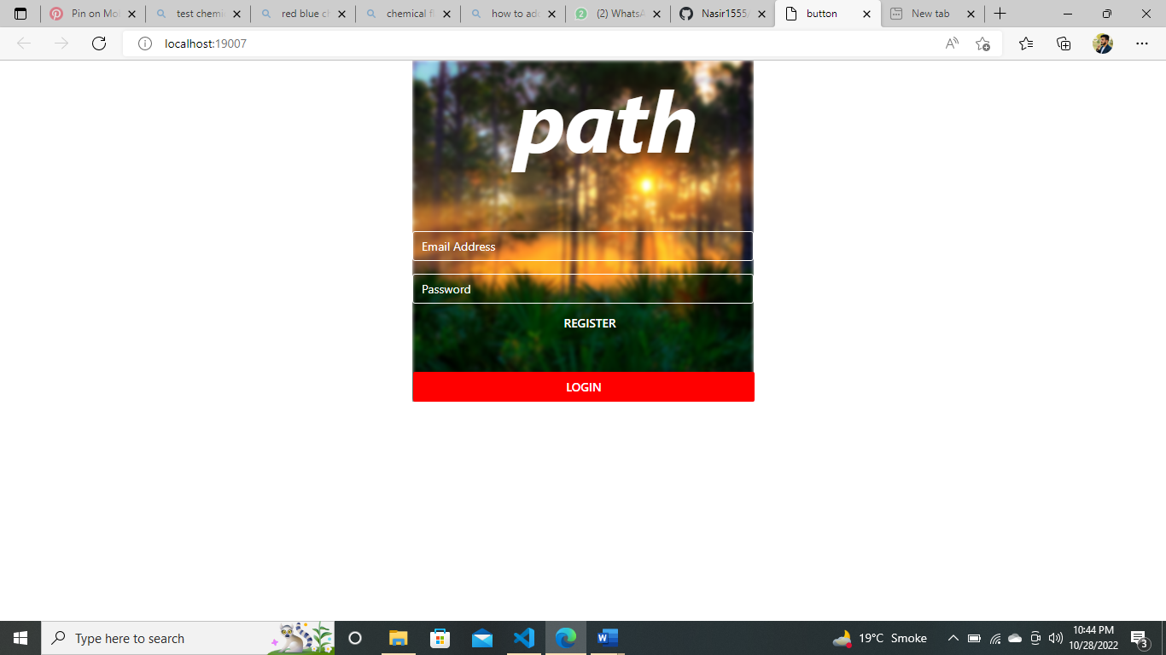

**Selected Design:**

<https://www.pinterest.com/pin/337418197056185893/>

